# How to Install Jenkins on Windows

[Jenkins](https://jenkins.io/) is one of the most popular tools for continuous integration and continuous delivery on any platform. A Java application, Jenkins has many plugins for automating almost everything at the infrastructure level. The use of Jenkins has widely increased rapidly due to a rich set of functionalities, which it provides in the form of plugins. In this tutorial, we will show a step by step guide on how to install Jenkins on a Windows platform.

## Requirements

First, you need to install JDK and MAVEN. Jenkins currently supports JDK8 and Apache-Maven-3.6.

### *Installing Steps of JDK*

* Downloading the JDK Installer

URL : <https://www.oracle.com/technetwork/java/javase/downloads/jdk8-downloads-2133151.html>

If you save the self-installing executable file to disk without running it from the download page at the web site, note the file size specified on the download page. After the download has completed, verify that you have downloaded the complete file.

* Running the JDK Installer

You must have administrative permissions in order to install the JDK on Microsoft Windows.

The file jdk-8version-windows-x64.exe is the JDK installer for 64-bit systems.

If you downloaded file instead of running it directly from the web site, double-click the installer's icon. Then, follow the instructions the installer provides. When finished with the installation, you can delete the downloaded file to recover disk space. In the server, we install JDK in C:\Program Files (x86)\Java\jdk1.8.0_151.

* Java Start Menu

After install is completed , Java menu items are added to the Windows Start Menu to provide easy access to Java resources. During JDK install, a Java Development Kit folder is created in the Windows Start Menu.

* Verify the JDK version

Click on the search button. Then type “cmd” (without quotes). Wait for the command prompt to open. Then, type “java -version” and press « Enter ». The above command prints the installed Java version.

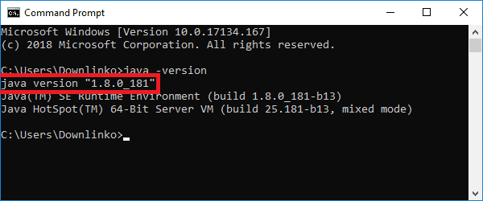

### *Installing Steps of Maven*

* Downloading the Maven Installer

URL : <https://archive.apache.org/dist/maven/maven-3/>

Click on the 3.3.9 folder. Then, click on binaries. And, click on the apache-maven-3.3.9-bin.zip link. Finally, wait for the download to complete.

* Install the Maven Installer

Open the location of the downloaded installer.

Right-click the ZIP archive file. Select Extract All….

Select an extract destination for the Maven files.

In the server, we extract in C:\Program Files (x86)\apache-maven-3.6.0.

### *set up of environment variables*

We need to set up two environment variables that will point to our JDK installation and Maven installation.

* On windows 10, Click on the search button. Then type “env”.
* Click on the Edit the system environment variables shortcut.
* Wait for the environment variables window to open.
* Click on « variables d’environnement »
* Click « nouvelle »

We have to add three environment variables named : JAVA_HOME with path of JDK, M2_Home and MAVEN_HOME with path of maven.

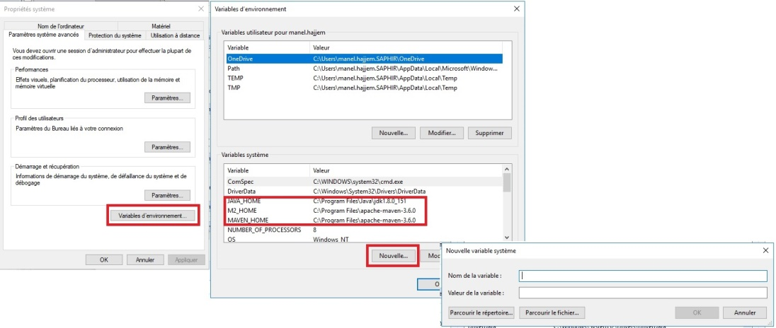

* Select the PATH variable. Click on Edit as shown bellow.
* Click on New and type “%M2_HOME%\bin”. Finally, click OK.
* Click on New and type “%JAVA_HOME%\bin”. Finally, click OK.
* Click on New and type “%MAVEN_HOME%\bin”. Finally, click OK.

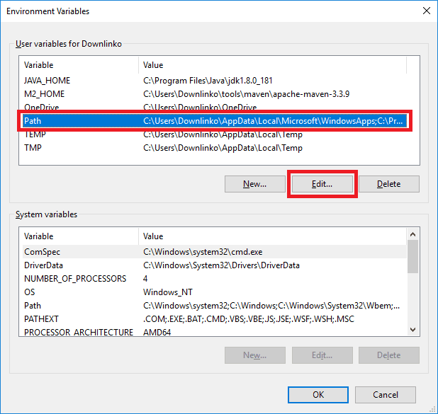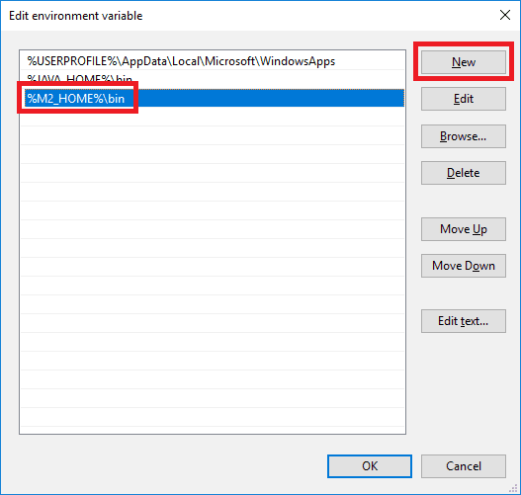

* Click OK once more to close the environment variables window.

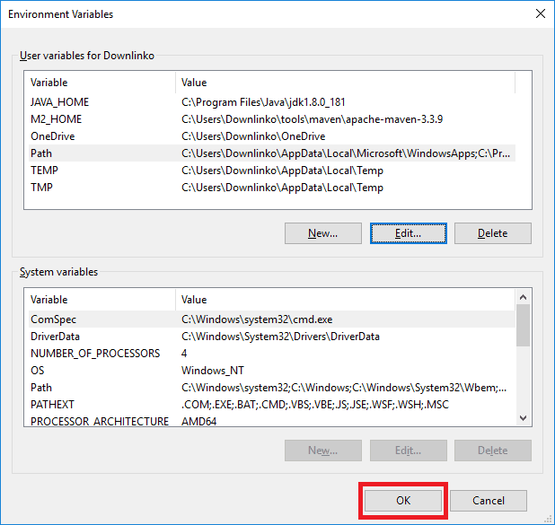

On Windows server you cannot add extra values for an existing Path variable. You need to append “;%M2_HOME%\bin” at the end of the path variable value instead.

### *Update google chrome and install chromeDriver*

The last step before installing jenkins in server we have to :

* install or update Googlechrome
* download and install chromeDriver : <https://chromedriver.storage.googleapis.com/index.html?path=2.38/>
* Install or update Firefox
* download and install geckodriver : https://github.com/mozilla/geckodriver/releases

## Installing Jenkins using War file

This manuel is described in the URL : <https://jenkins.io/doc/book/installing/>

The Web application ARchive (WAR) file version of Jenkins can be installed on any operating system or platform that supports Java.

**To download and run the WAR file version of Jenkins:**

* Download the [latest stable Jenkins WAR file](http://mirrors.jenkins.io/war-stable/latest/jenkins.war) to an appropriate directory on your machine.
* Open up a terminal/command prompt window to the download directory.
* Run the command java -jar jenkins.war.
* Browse to http://localhost:8080 and wait until the **Unlock Jenkins** page appears.
* Continue on with the [Post-installation setup wizard](https://jenkins.io/doc/book/installing/#setup-wizard) below.

**Notes:**

You can change the port by specifying the --httpPort option when you run the java -jar jenkins.war command. For example, to make Jenkins accessible through port 9090, then run Jenkins using the command:  
java -jar jenkins.war --httpPort=9090

## Installing Jenkins using Jenkins package for Windows (currently it is version 2.130)

Click to download the latest Jenkins package for Windows (currently it is version 2.130).

Unzip the file to a folder and click on the Jenkins **exe** file.

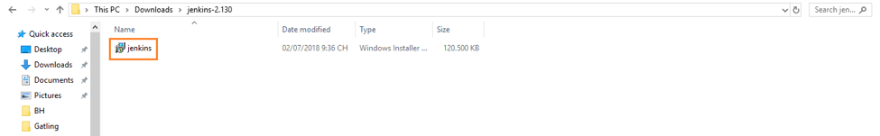

Click **“Next”** to start the installation.

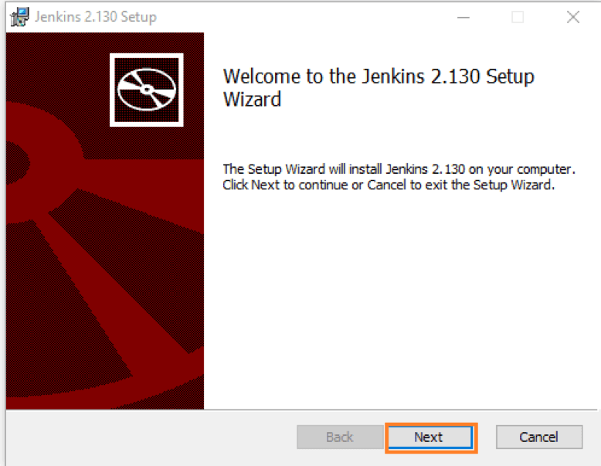

Click the **“Change…”** button if you want to install Jenkins in another folder. In this example I will keep the default option and click on the **“Next”** button.

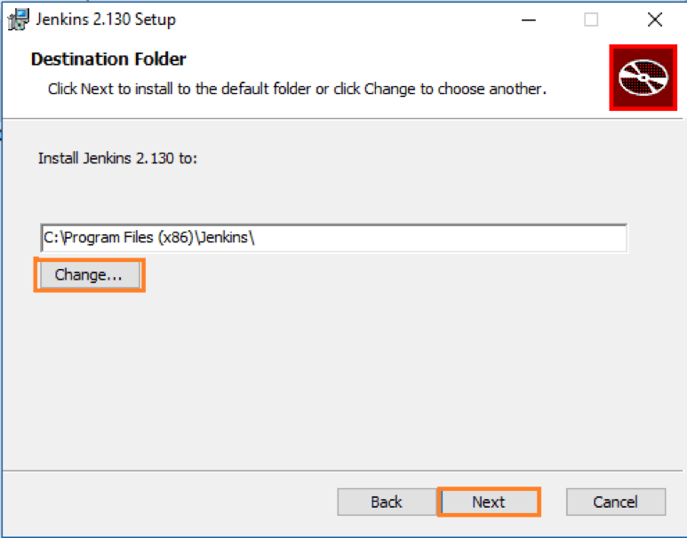

Click the **“Install”** button to start the installation process.

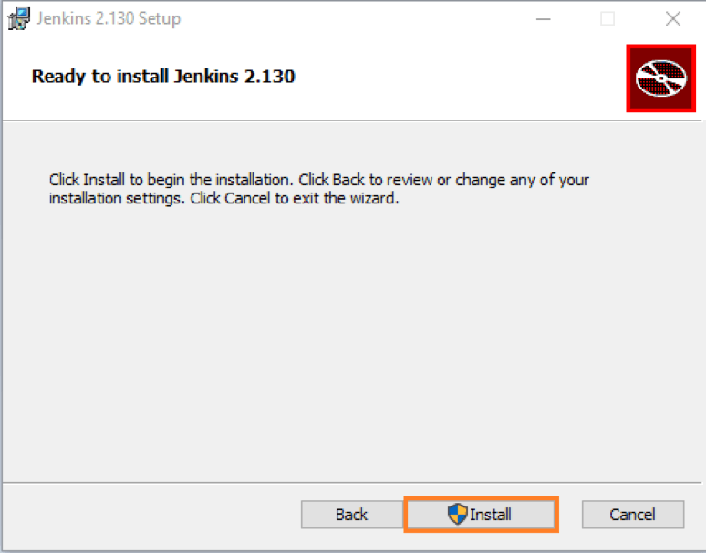

The installation is processing.

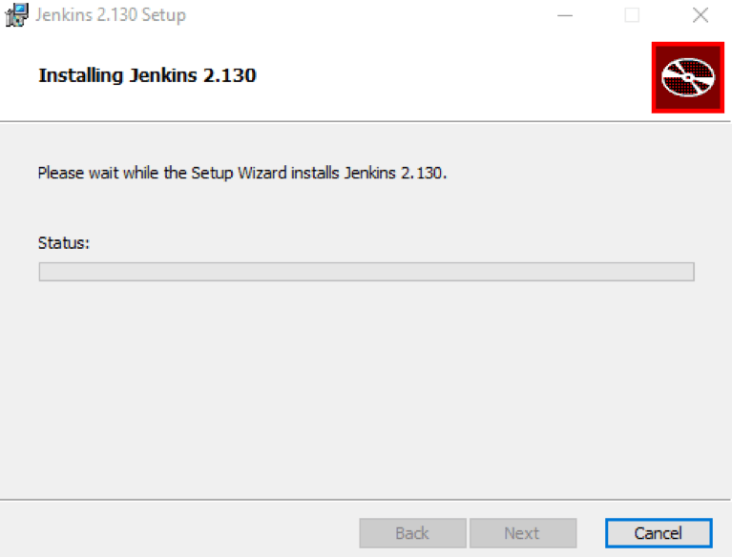

When done, click the **“Finish”** button to complete the installation process.

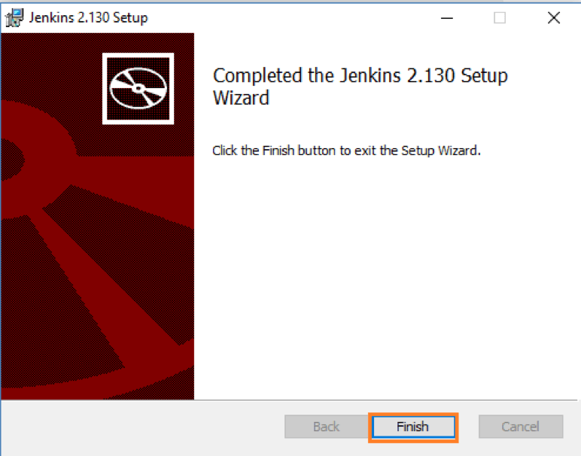

You will automatically be redirected to a local Jenkins page, or you can paste the URL [http://localhost:8080](http://localhost:8080/) in a browser.

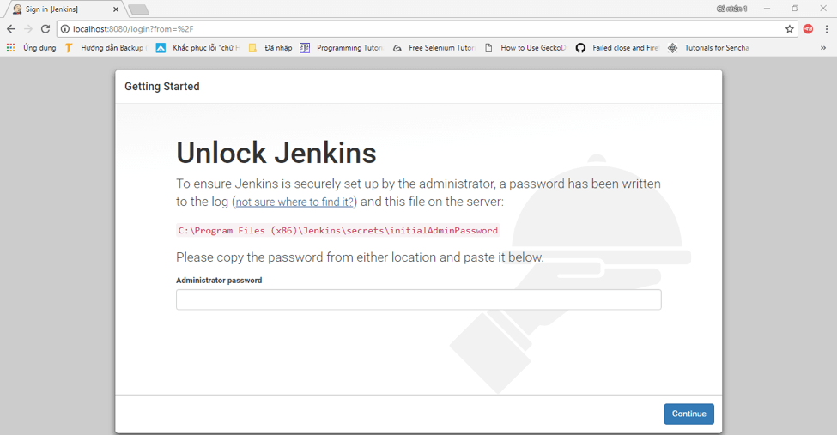

To unlock Jenkins, copy the password from the file at **C:\Program Files (x86)\Jenkins\secrets\initialAdminPassword** and paste it in the **Administrator** **password** field. Then, click the **“Continue”** button.

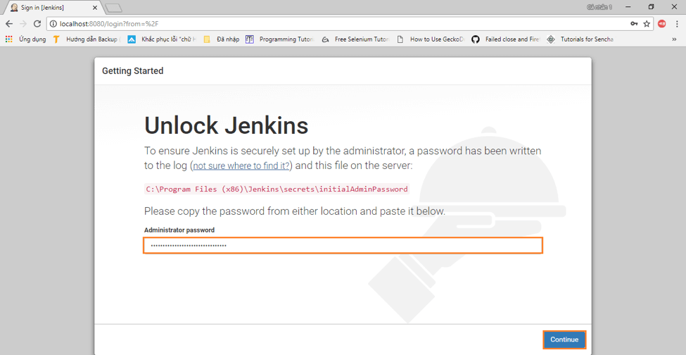

You can install either the suggested plugins or selected plugins you choose. To keep it simple, we will install the suggested plugins.

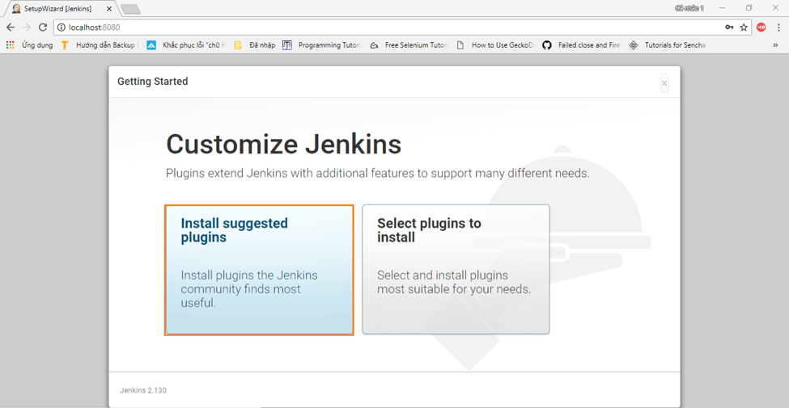

Wait until the plugins are completely installed.

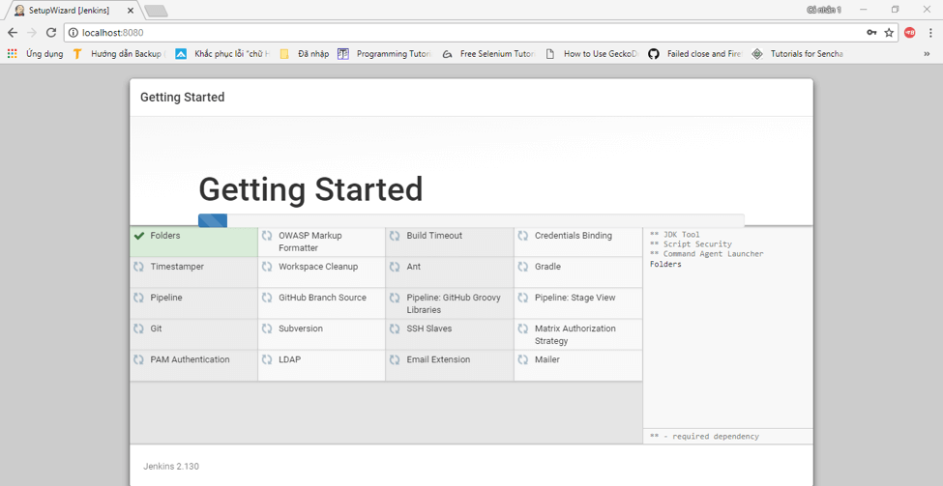

The next thing we should do is create an admin user for Jenkins. Put in your details and click **“Save and Continue”**.

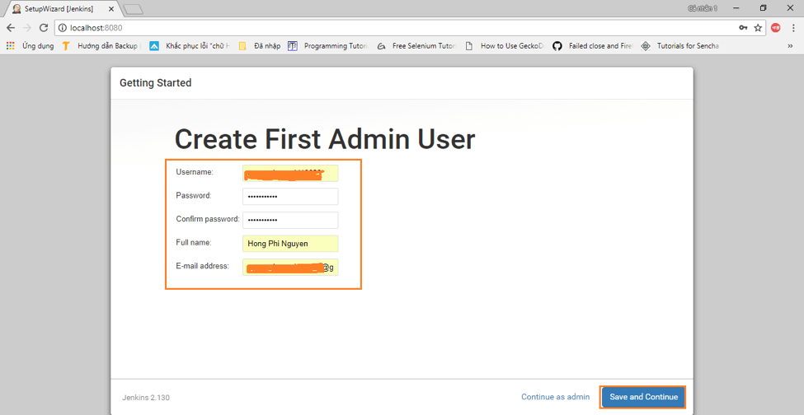

Click **“Save and Finish”** to complete the Jenkins installation.

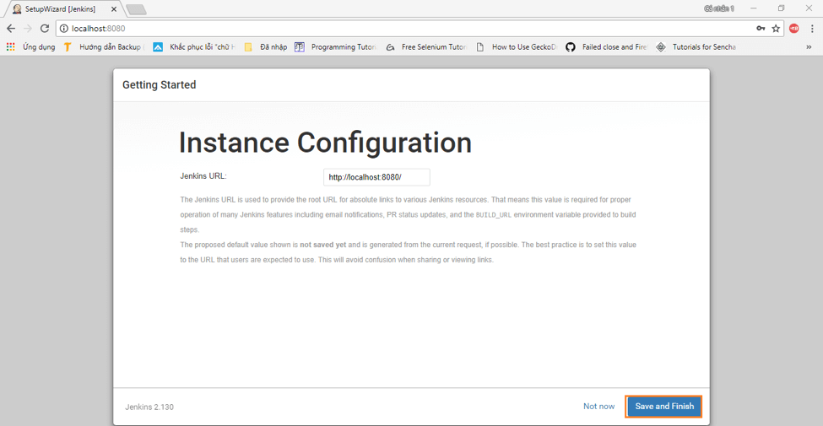

Now, click **“Start using Jenkins”** to start Jenkins.

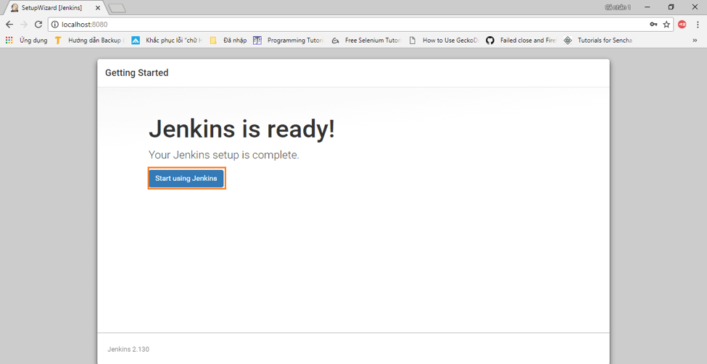

Finally, here is the default Jenkins page.

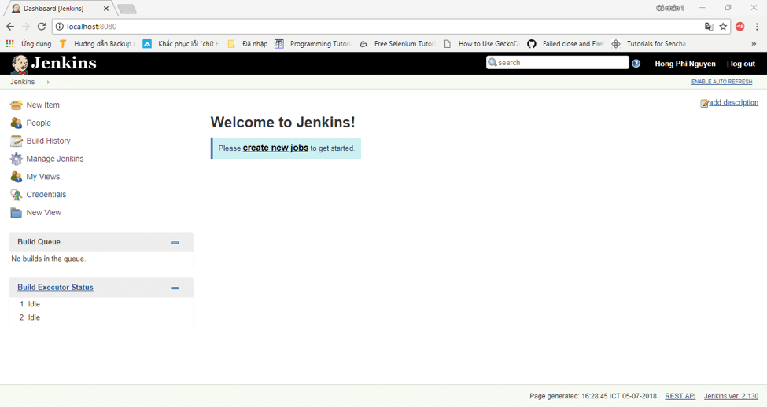

# Jenkins Configuration

Once jenkins is installed, we have to configure JDK and Maven in jenkins

* Click on jenkins administor

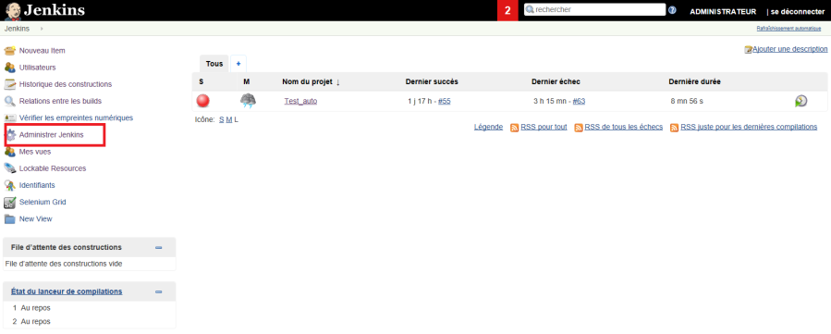

* Click on system configuration

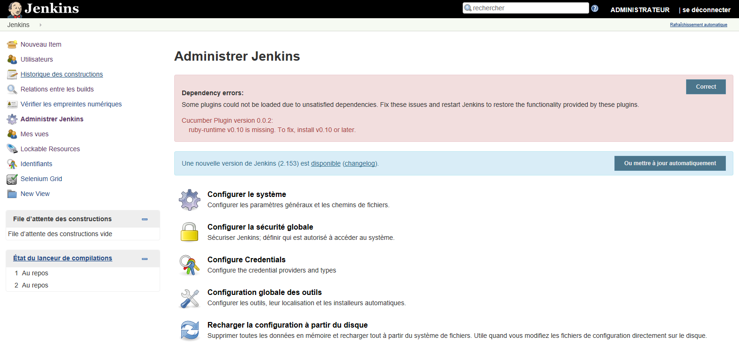

* Add in JDK install the JAVA_HOME and its path used in the *environment variables*.

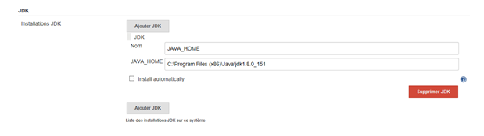

* Add in Maven install the MAVEN_HOME and its path used in the *environment variables*.

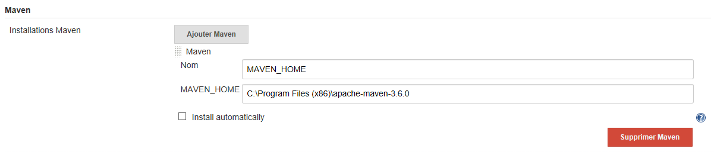

# Adding project

## Adding job

* Go to New Items
* Give a project name in “Item name” field
* select Maven project
* click OK

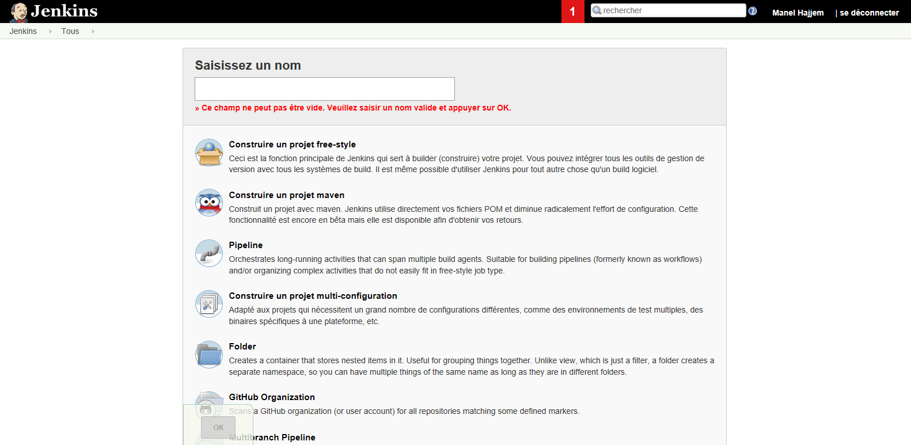

## Configuration of the job

* click on created job

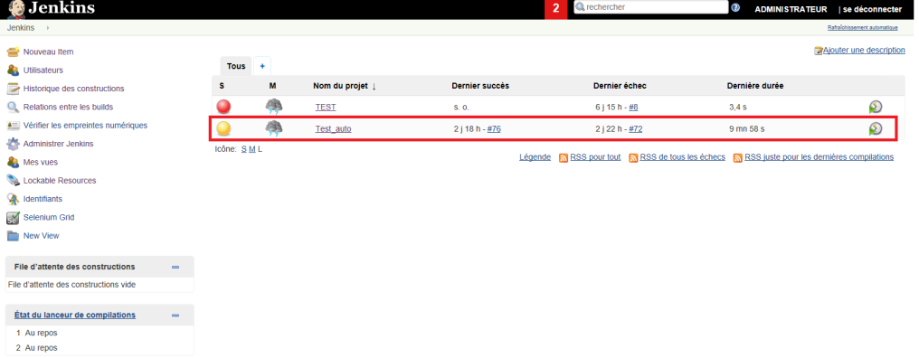

* Click on configure

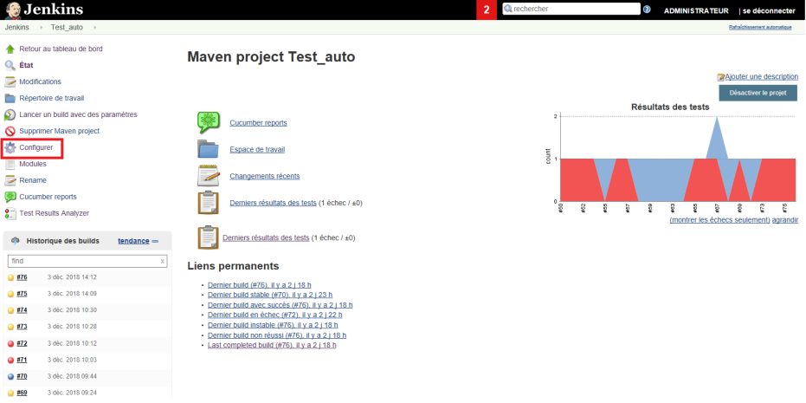

On Configure Page, set the following:

* Check discard Old builds
* Define days to keep builds: 1
* Define max of builds to keep: 15

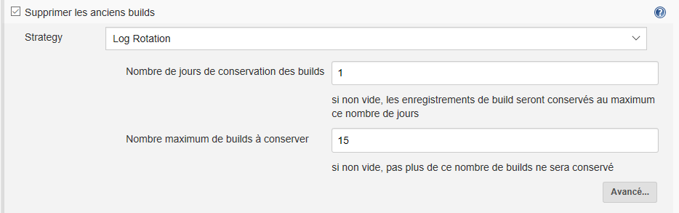

* Click on build
* Set POM Racine : pom.xml
* Set Goals and option : Clean Compile Test (build without parameter : only one xml file in the pom)
* Set Goals and option : test –Dsurefire.suiteXmlFiles=$TestngFile (build with parameter : parameterized pom) we will defines in the following each varibale in this script

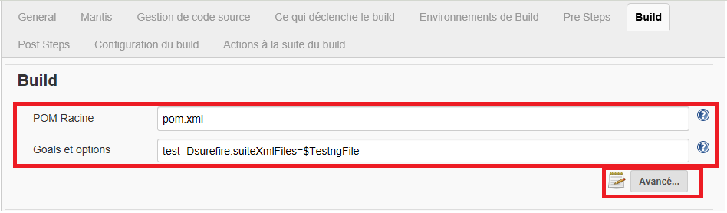

* Click on adavanced
* Enable the following :
* Resolve Dependencies during Pom parsing
* Use custom workspace (add path of the folder containing pom.xml)

Our Path should be as in server : E:\qualipro\trunk\AutomatisationTQualiPro_prod

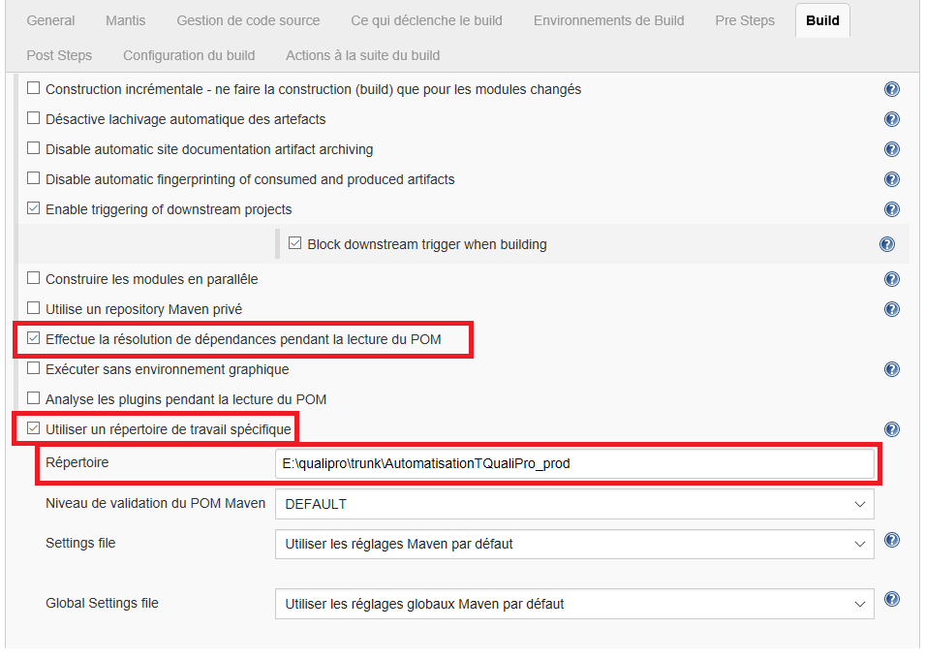

* Check this buils has parameters
* click the Add Parameter button,
* select the parameter type to add. choose "Choice Parameter".

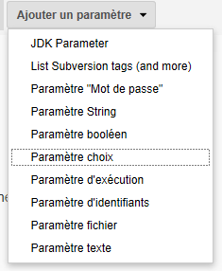

* Define the name « TestngFile » to the set of xml file. This name is used in the goal in order to define the pom to the set of xml file

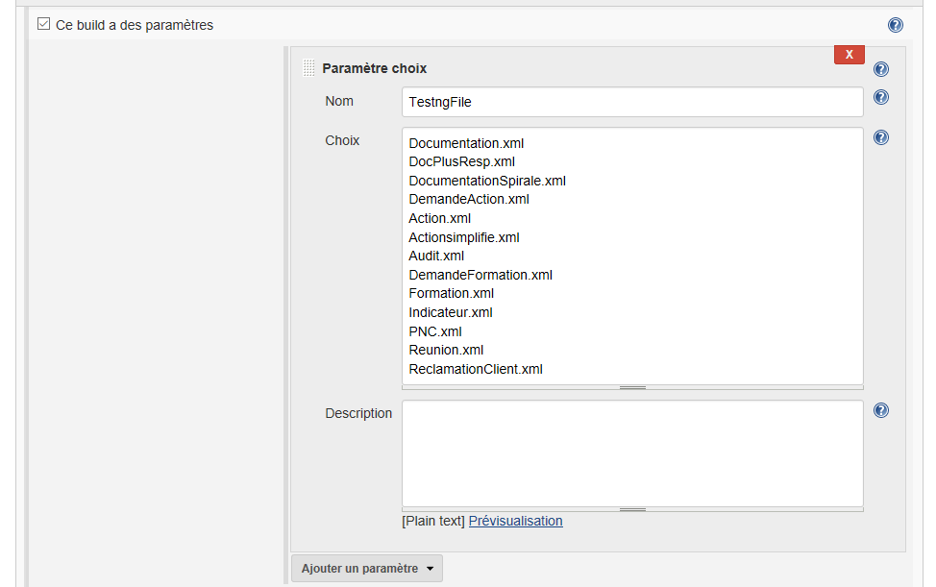

Set of xml files that should be build

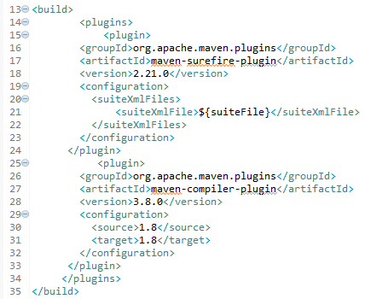

In order to be run with maven , the pom.xml of our porject should be modified by adding maven-compiler-plugin

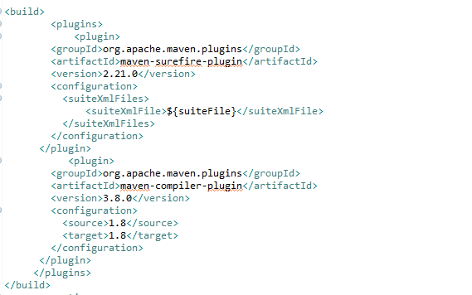

# Mantis Configuration

This plugin integrates [Mantis Bug Tracker](http://www.mantisbt.org/) to Jenkins. Mantis is a free popular web-based bugtracking system written in PHP scripting language. This plugin decorates Hudson "Changes" HTML to create links to your Mantis issues, and update issues with private / public notes.

## Install plugin

First you need to install mantis plugin :

* Click on jenkins administor



* Click on Plugin managment

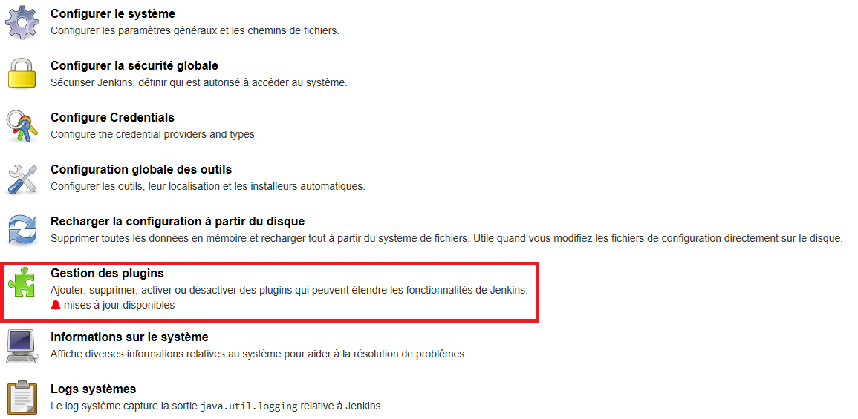

* Click on available plugin. Then set mantis on research zone and check mantis plugin. Finally click on install without restart.

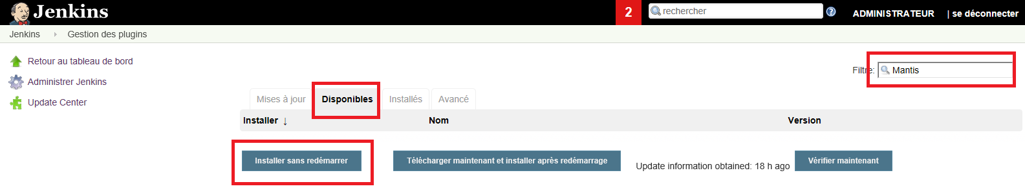

## System Configuration

* You need to go to system config screen to tell Jenkins where's your Mantis.
* Set the root URL of your Mantis installation. (While jenkins is installed on server, we have to use localhost URL of Mantis : http://localhost/mantis/)
* Set the version of your Mantis installation. 1.1.X or 1.2.X(1.2.0a3 and later, this is experimental)
* Set User user name and password of your Mantis installation to update relevant Mantis issues.
* Click on advanced buttom to Verify if login and password are correct

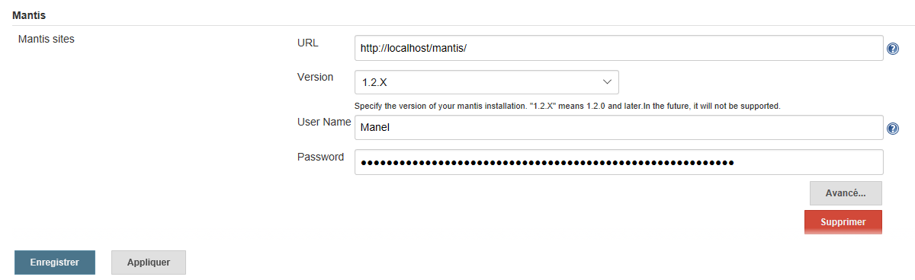

* Set user name and password of your Mantis installation on http basic Authentification window
* Click on verify buttom
* Check if state set is verified
* Click on apply then save.

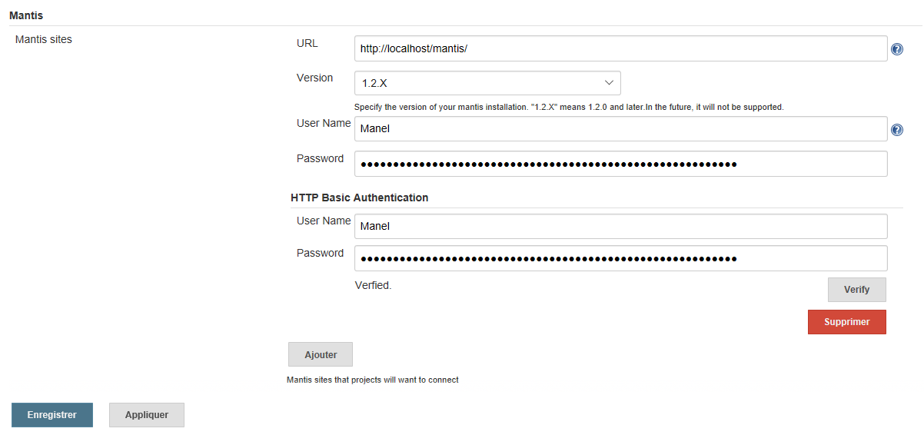

## Project Configuration

Click on configure of your project

In the top Mantis section :

* select the url of your Mantis installation
* Select the Project and Category is mandatory for "File a ticket when build is broken or unstable".
* Update Mantis issue as follows :[ISSUE : %ID%] Where %ID% is placeholder which means Mantis issue id.

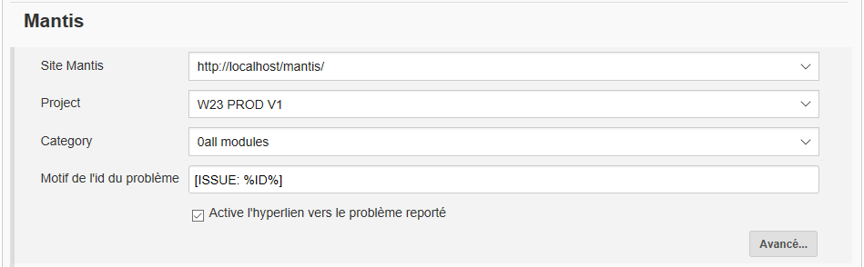

* In the Post-build Actions section, choose "Updated relevant Mantis issues" (option).   
  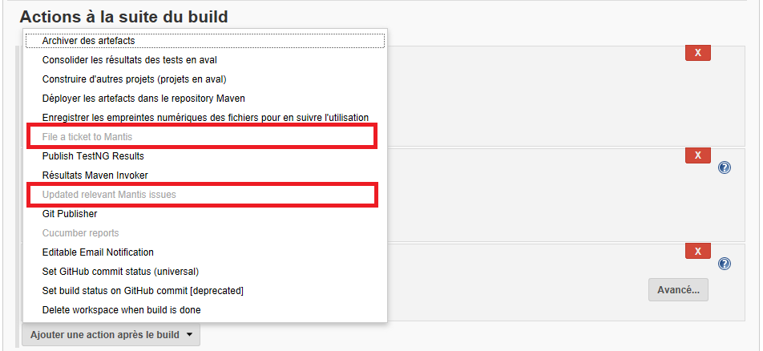
* This plugin updates Mantis issues if build is stable or unstable.
* File a ticket if build is broken or unstable
* In the Post-build Actions section, choose "File a ticket to Mantis" (option).

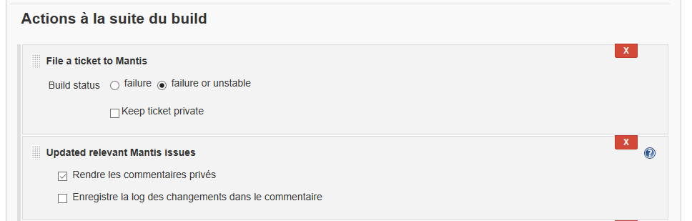

* Now Mantis is integrated and an example of a bogue is presented :

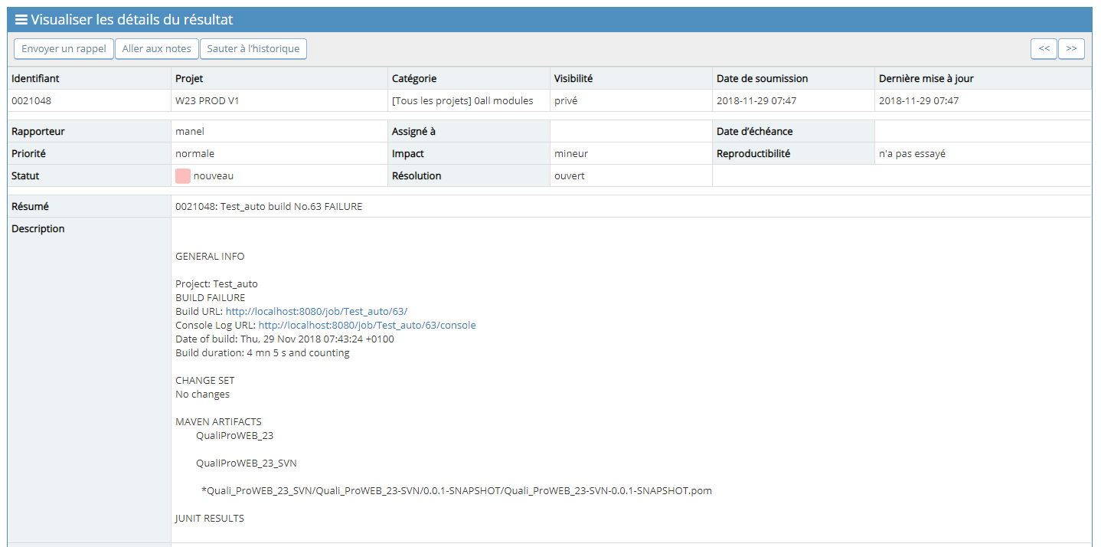

# Cucumber report Configuration

## Install the Jenkins cucumber plugin

* Click the manage Jenkins link on the left hand navigation:

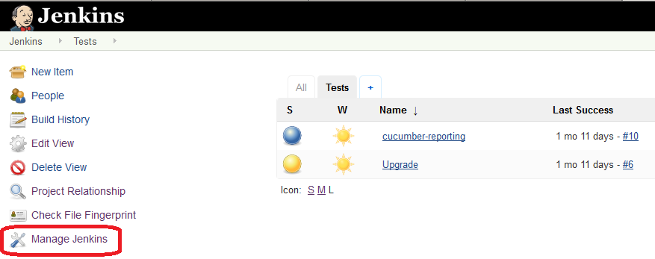

* Click Manage Plugins

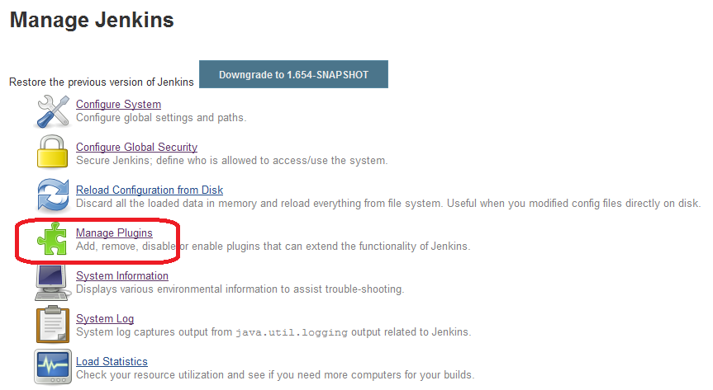

* Click Available Tab on the Manage Plugins Page
* Check Cucumber reports
* Check Cucumber plugin
* Click install without restart

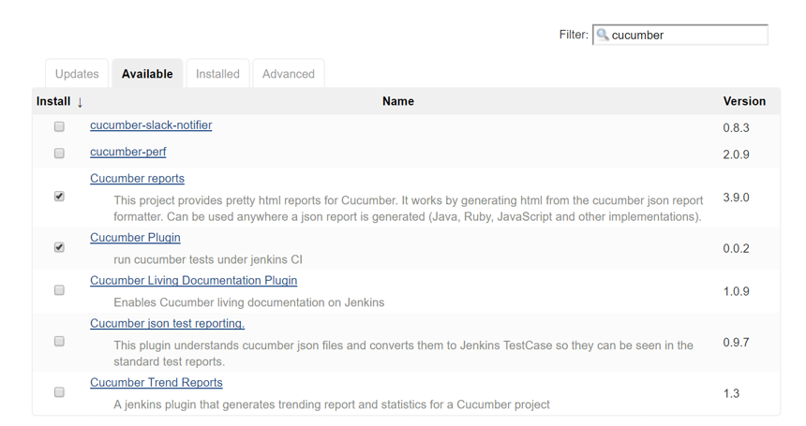

* Check the Restart Jenkins when installation is complete and no jobs are running box

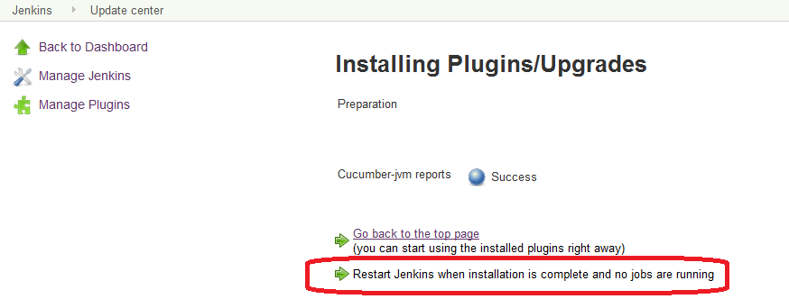

## Configure the Plugin of your job

* Open the configuration page for your job,
* Click add a post build
* Check Cucumber reports

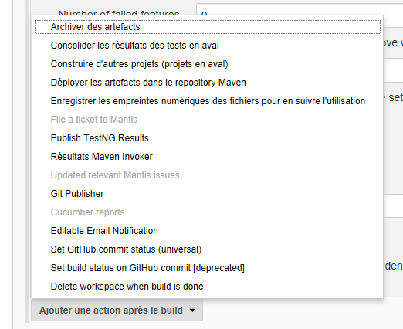

* Set in File Include Pattern : **/*.json

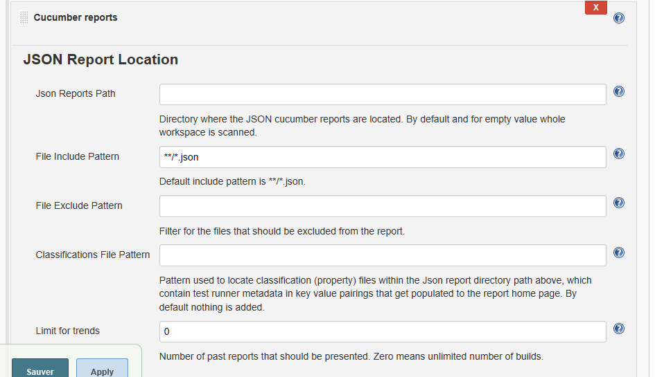

## Link to the report

* Once the report is generated you can open it via link displayed on project details panel or on the job panel

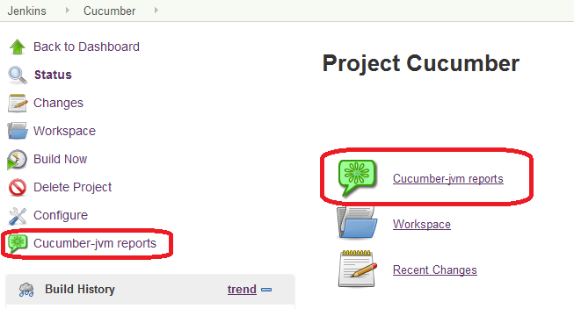

# TestLink Configuration

## Install plugin

Since, existing Testlink plugin is not compatible with testlink1.9.2, we have to download testlink plugin 2.4 and install it in jenkins

* Download the file hpi of testlink plugin 2.4 from <https://javalibs.com/artifact/org.jvnet.hudson.plugins/testlink>;
* Click the manage Jenkins link on the left hand navigation:



* Click Manage Plugins



* Click Advanced Tab on the Manage Plugins Page
* Choose the .hpi file under the **Upload Plugin** section.
* **Upload** the plugin file.

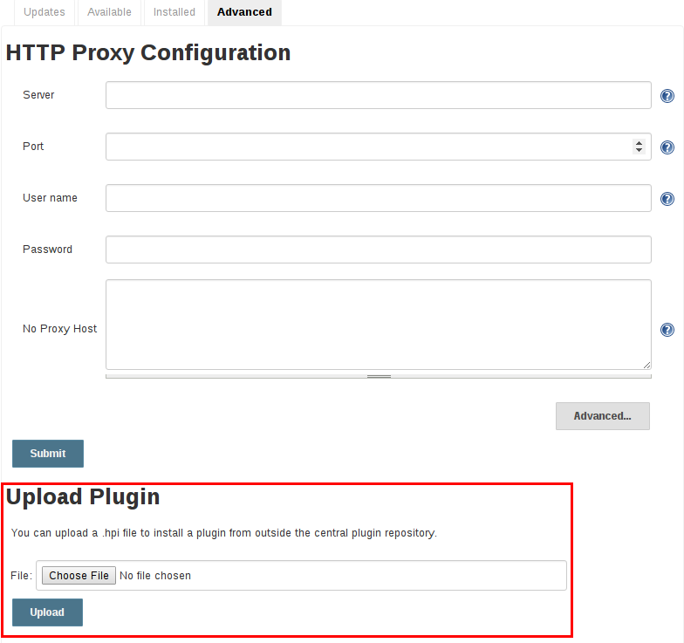

* Once a plugin file has been uploaded, the Jenkins master must be manually restarted in order for the changes to take effect.
* Add available plugin : TestNG results plugin

## Configure jenkins

file:///C:/Users/manel.hajjem.SAPHIR/AppData/Local/Packages/Microsoft.MicrosoftEdge_8wekyb3d8bbwe/TempState/Downloads/jenkins%20(1).pdf

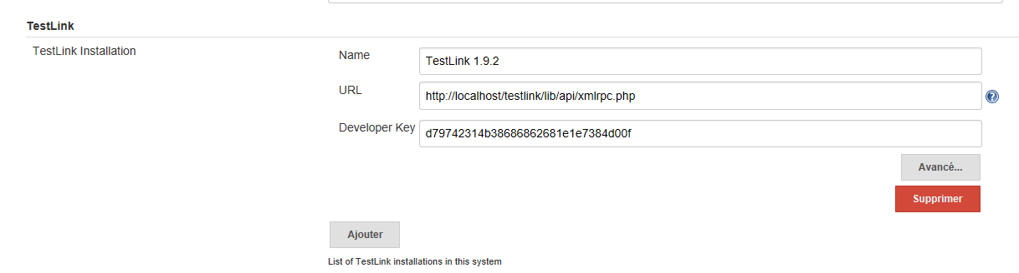

## Configure TestLink

* **Creating and assigning a Custom Field**

Click on the Project item of the top menu to be redirected to the main screen. Now we will create the custom field used for automation. The plug-in uses this custom field's value to link a test case in TestLink with a test result from your Jenkins build.

* Click on Define Custom Fields under the Test Project options box.

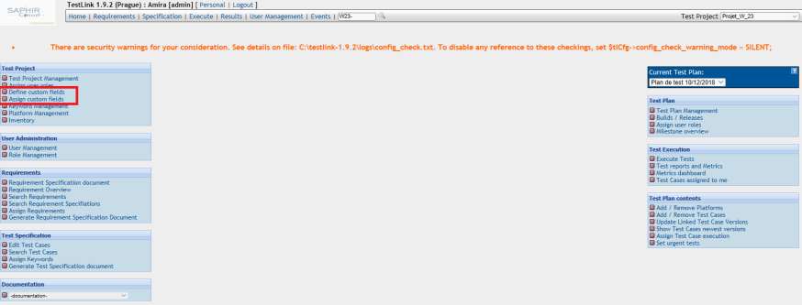

Now create a custom field using the name Java Class, label Java Class, available for Test Case, type string, enable on Test Spec Design and display on test execution No. The plug-in retrieves the custom fields by its name and not by the value in its label.



* Assign this custom field to be used in our test project.

Go back to the main screen and click on Assign Custom Fields. It will take you to a screen with the list of the available custom fields. Select the Java Class custom field and click on the Assign button.

* Define Custom field for each Test case

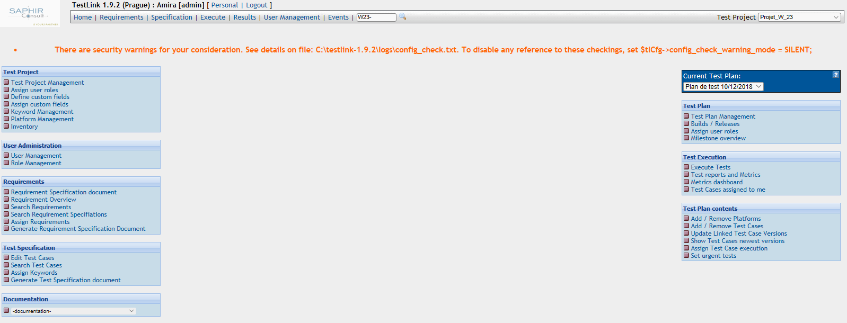

The important information on this screen for the automation are the execution type and the Java class (custom field created in the previous step).

* Execution type select : Automated
* Java class fill with the class runner related to the test case : In our case we have to set : com.qualiprobdd.e2etests.**Runner

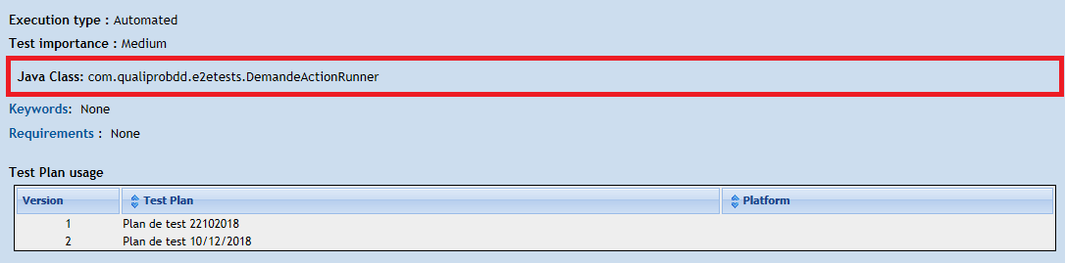

* **Creating and assigning a Platform**
* **Click on Platform management**

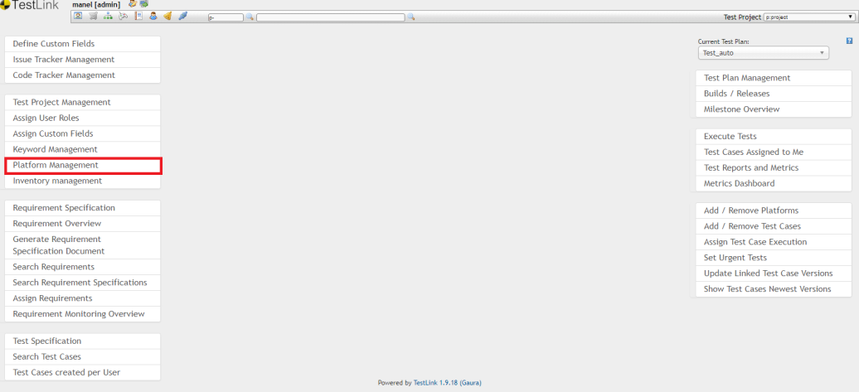

* Click create Platform
* Set the name of the platform
* Click Save

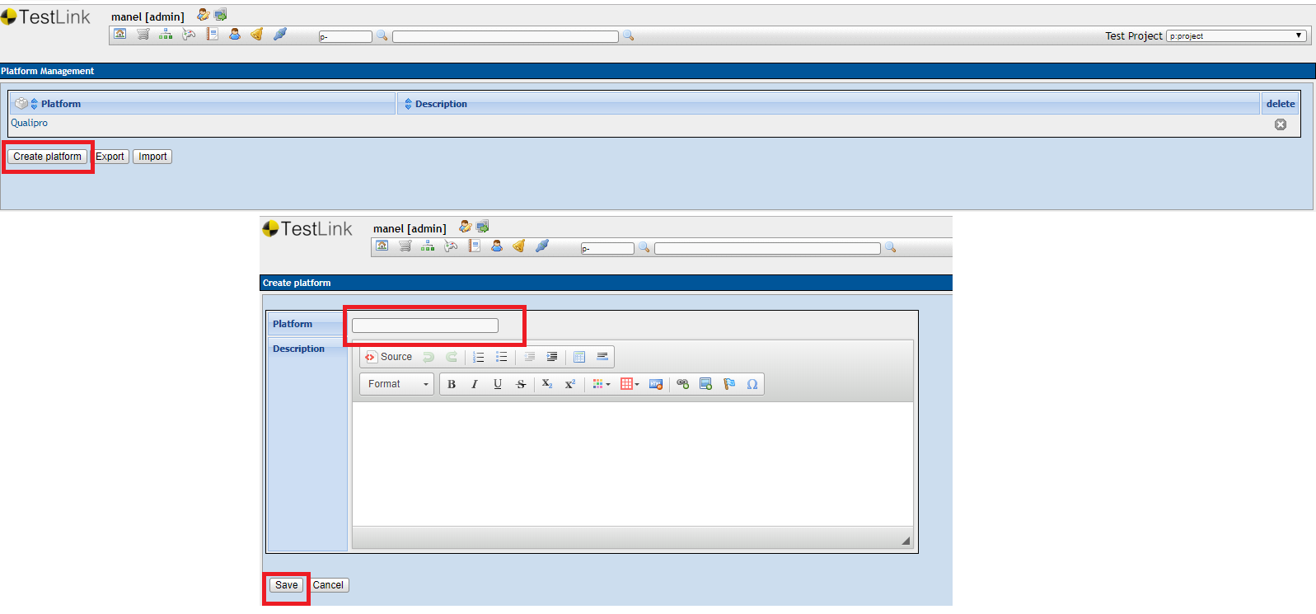

* Click on Add/remove platform

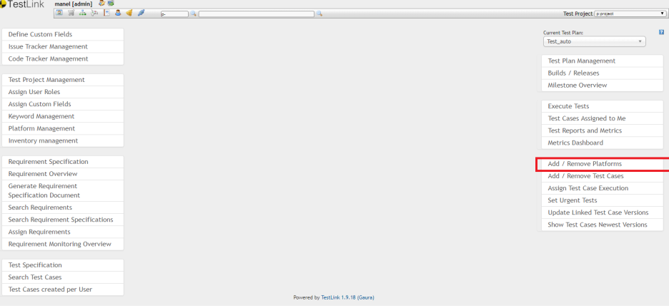

* Select the created platform
* Deplace this platform to « Assigned platforms »
* Click on save

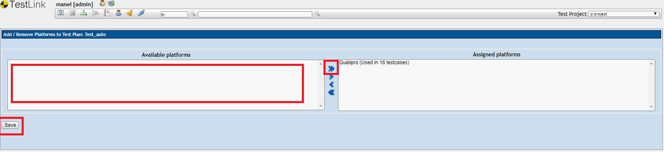

## Configure project

Our job > Configure > Add a post step > Invoke TestLink

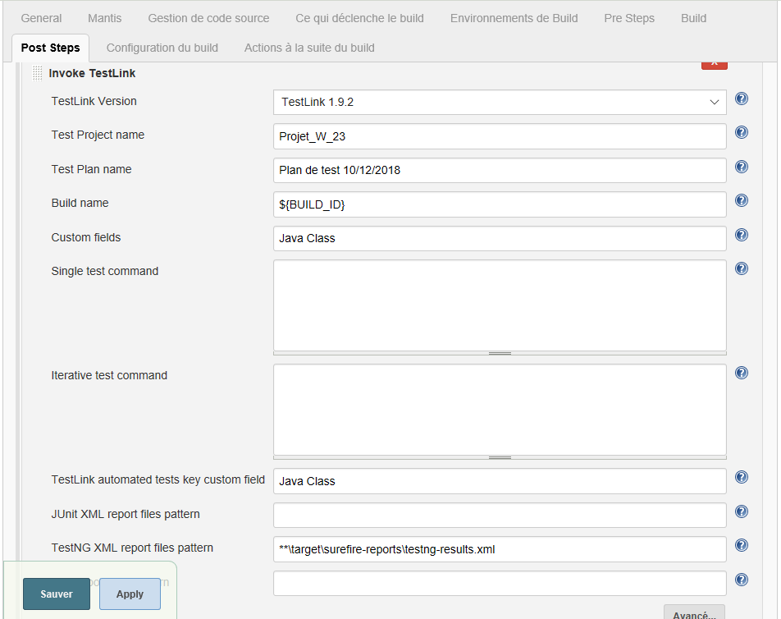

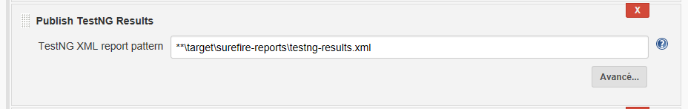

**TestLink Version** : this is the name of your TestLink installation in Jenkins global configuration.

**Test Project Name** : this is the name of your Test Project in TestLink. You can use environment variables in this field.

**Test Plan name :** this is the name of your Test Plan in TestLink. You can use environment variables in this field.

**Build Name**: this is the name of your Build in TestLink. You can use environment variables in this field. You can use the build id « ${BUILD_ID} » to generate a new build in testlink for each build in jenkins

We propose to rename build by date that is why, we set « Build_Auto_FR_${BUILD_TIMESTAMP} » in build name.

To add Build Timestamp Plugin, follow the below Simple steps to get the "BUILD_TIMESTAMP" variable enabled.

* **STEP 1:**

Manage Jenkins -> Plugin Manager -> Available

Search for "Build Timestamp Plugin".

Install with or without Restart.

* **STEP 2:**

Manage Jenkins -> Configure System.

Search for 'Build Timestamp' section, then Enable the CHECKBOX.

Select the TIMEZONE, TIME format you want to setup with..Save the Page.

* **USAGE:**

Build name = Build_Auto_FR_${BUILD_TIMESTAMP}

**Custom fields :** this is a comma separated list of Custom Fields in TestLink. Only the custom fields present here are retrieved from TestLink.

**Key Custom Field :** this is the custom field used by the plug-in to link a test case in TestLink with your test results. This custom field must exist in the list of custom fields.

**Platform Name :** this is the name of your Used Platform in TestLink. You can use environment variables in this field.

# Rename build in jenkins

# Install the [Build Name Setter Plugin](https://wiki.jenkins.io/display/JENKINS/Build+Name+Setter+Plugin)

* Click the manage Jenkins link on the left hand navigation:



* Click Manage Plugins



* Click Available Tab on the Manage Plugins Page
* Check the [Build Name Setter Plugin](https://wiki.jenkins.io/display/JENKINS/Build+Name+Setter+Plugin)
* Click install without restart
* Restart jenkins

# Project Configuration

Click on configure of your project

In the Build Environment:

* Check « Set Build Name »
* Add the environment variable of the parameters in order to get the parameter name in the build name « -${ENV,var="TestngFile"} » with TestngFile is the parameter name

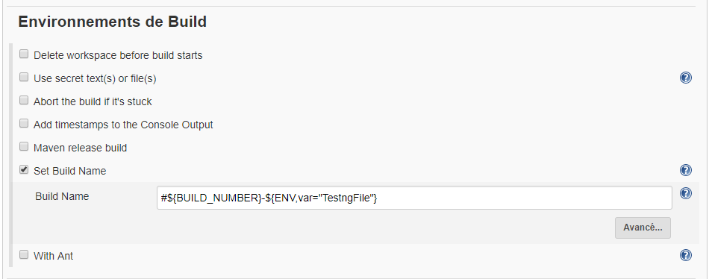

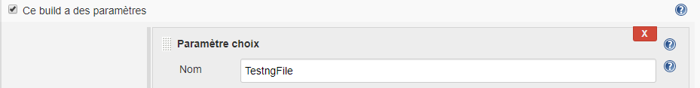

# User Management

## Add new user

* Click on system configuration
* Click on users management

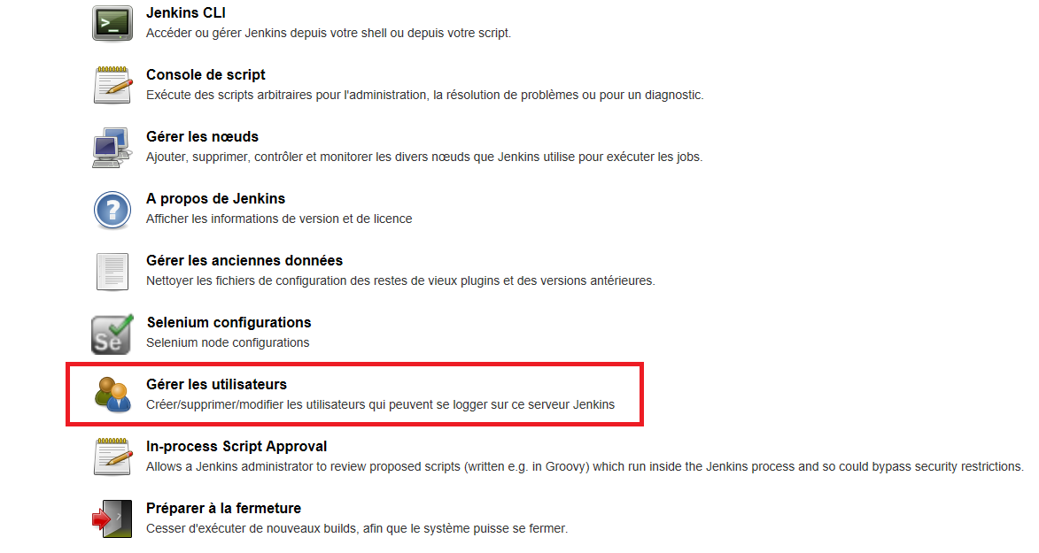

* Click on create new user

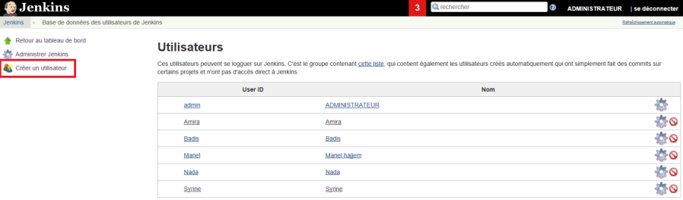

* Set the login, password, password confirmation, Complet name, email
* Click on create user

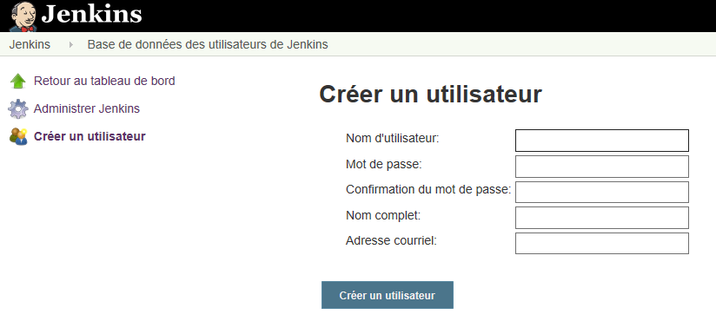

* Now, your name will be visible in the user gridview

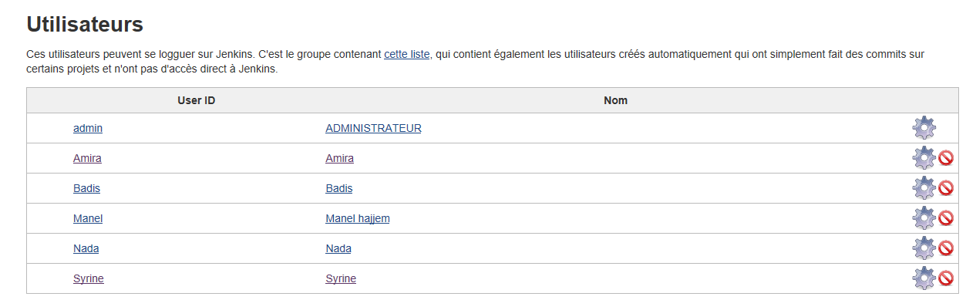

## Access Management

* Click on jenkins configuration
* Click on configure global security

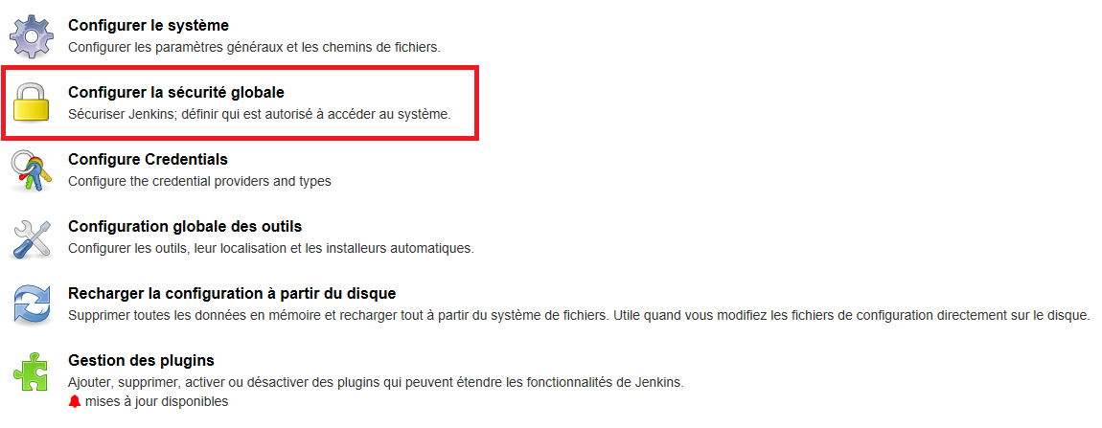

* Check Matrice based Security
* Click Add user to add a user for managment acess

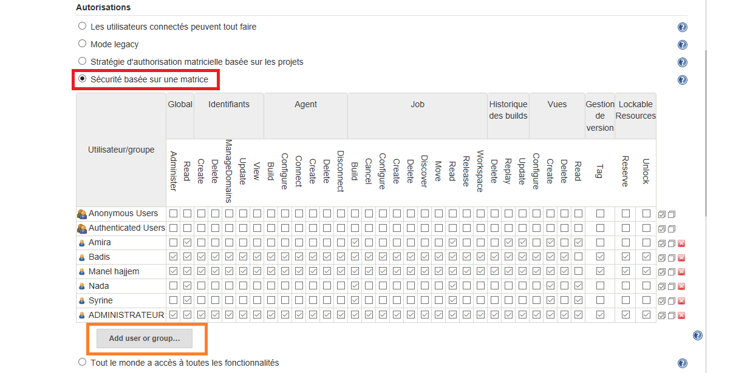

* Set the name of user
* Click ok

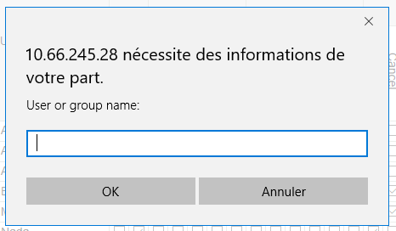

* Two type of access can be defined
* Administor access (red definition)
* User access (green definition)

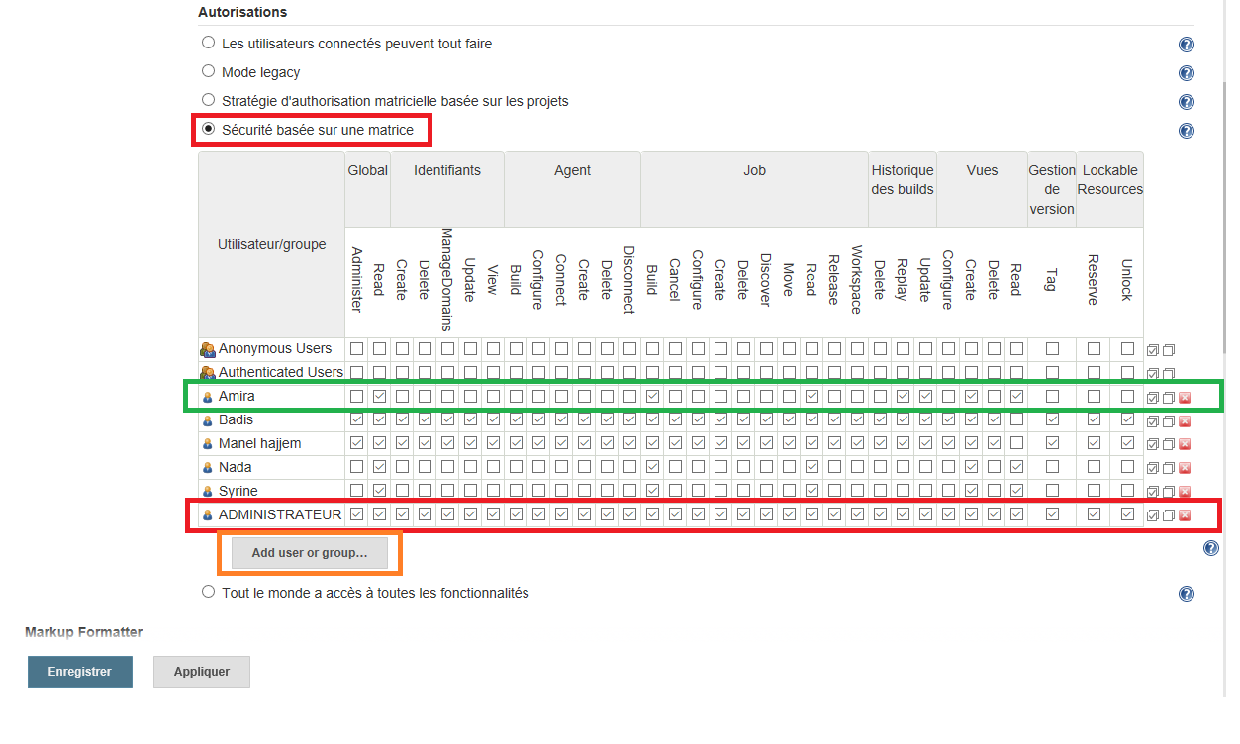

# Night job

## Install the Parameterized-schedular plugin

* Click the manage Jenkins link on the left hand navigation:



* Click Manage Plugins



* Click Available Tab on the Manage Plugins Page

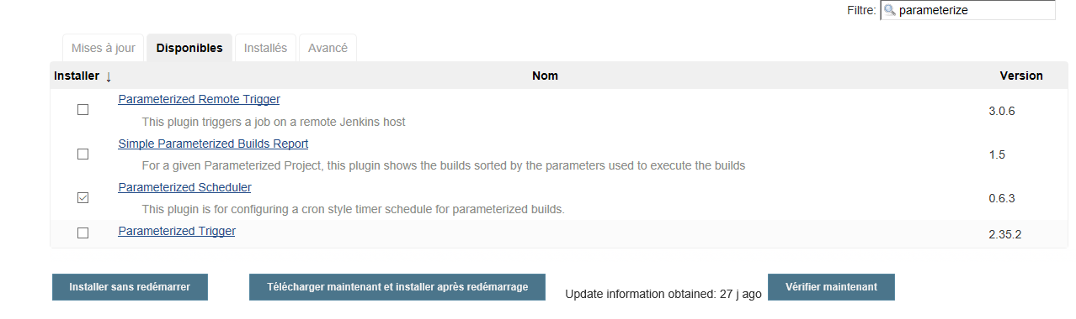

* Check Parameterized-schedular
* Click install without restart
* Restart jenkins

## Project Configuration

Click on configure of your project

In the Build Triggers:

* Check « Build periodically with parameters »
* Update schedule list with setting the pervious time to build the job with each parameter

# Mailing configuration

1. Open Jenkins using the following URL: http://localhost:8080/ on any browser.

2. Click the ‘Manage Jenkins’ menu option displayed at the right side of the screen. You will be redirected to the ‘Manage Jenkins’ page, where you need to select the ‘Manage Plugin’ option.

[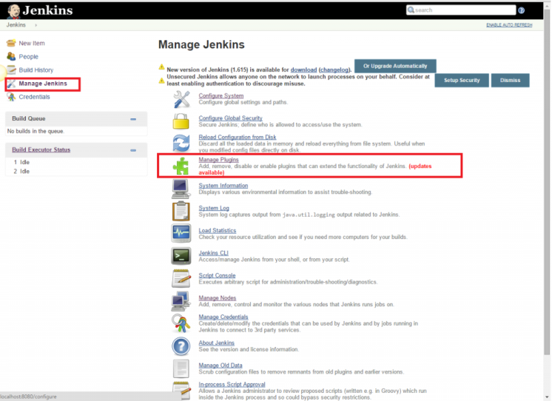](http://www.360logica.com/blog/wp-content/uploads/2016/02/image002.png)

3. Click the ‘Available’ tab present at the top of the ‘Manage Plugin’ page.

[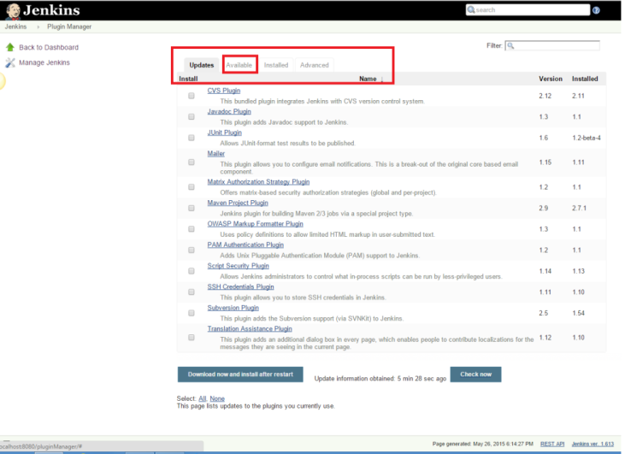](http://www.360logica.com/blog/wp-content/uploads/2016/02/image003.png)

4. Start typing ‘Notification’ in the ‘Filter’ field displayed at the top-right side of the ‘Manage Plugin’ page. Click the checkbox next to the ‘Email-ext plugin’ option. Click the ‘Install without restart’ button.

[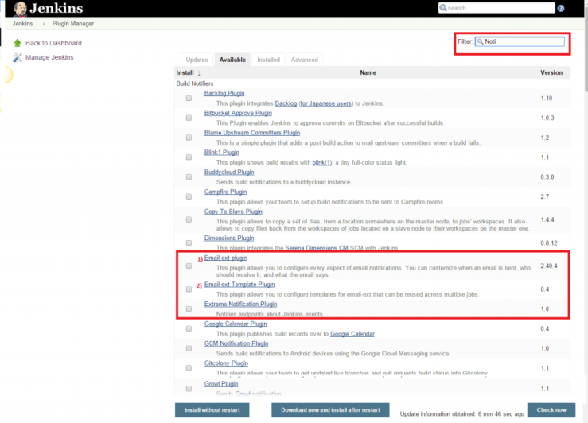](http://www.360logica.com/blog/wp-content/uploads/2016/02/image004.png)

5. Now, click the checkbox next to the ‘Email-ext Template Plugin’ option. Click the ‘Install without restart’ button.

[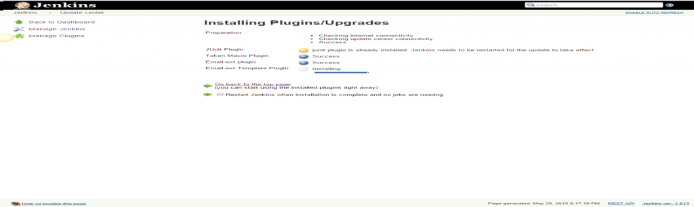](http://www.360logica.com/blog/wp-content/uploads/2016/02/image005.png)

6. Go to the Jenkins home page and click the ‘Manage Jenkins’ menu option. Then, select the ‘Configure System’ option.

[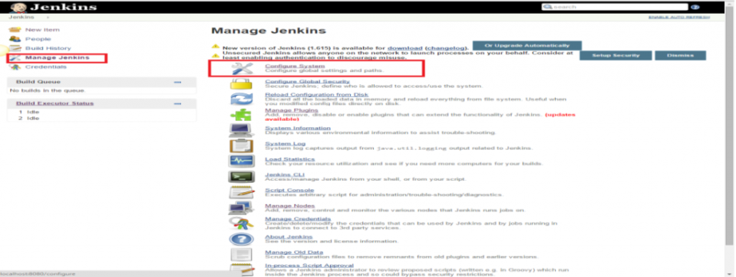](http://www.360logica.com/blog/wp-content/uploads/2016/02/image006.png)

7. Enter the SMTP server name under ‘Email Notification’. Click the ‘Advanced’ button and then click the checkbox next to the ‘Use SMTP Authentication’ option. Now, set the following fields.

* + **SMTP server name** : smtp.gmail.com
  + **User name**: hajjem.manel@gmail.com
  + **Password**: *************
  + **Use SSL**: Checked
  + **SMTP Port**: 465

8. Check the email notification functionality by clicking the checkbox next to the ‘Test configuration by sending Test e-mail recipient’ option. Enter a valid email id and click the ‘Test configuration’ button to check whether the email id is valid or not.

[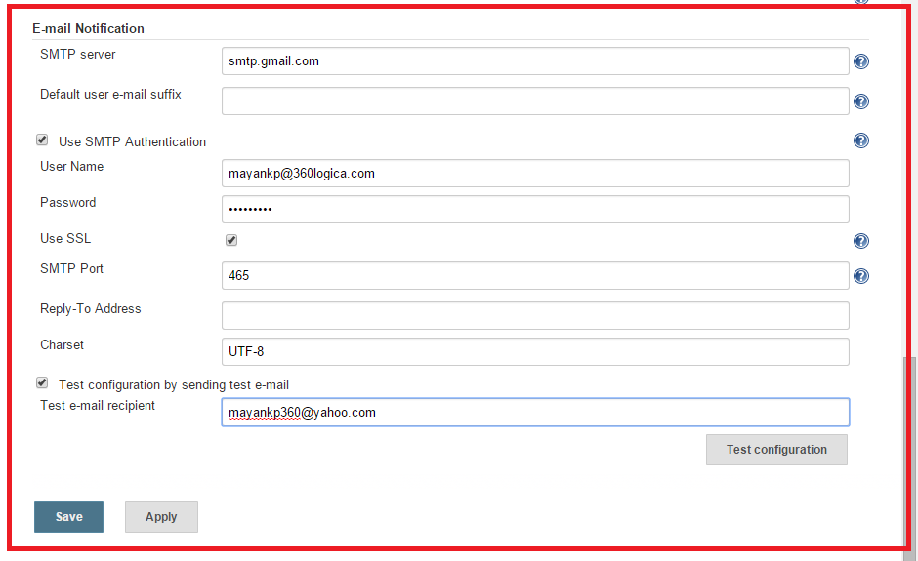](http://www.360logica.com/blog/wp-content/uploads/2016/02/image008.png)

9. Go to the home page and click on a created job, like Homes. Then, click the ‘Configure’ option.

[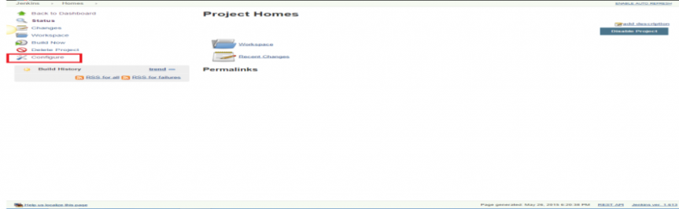](http://www.360logica.com/blog/wp-content/uploads/2016/02/image010.png)

10. Click the ‘Add post-build action’ drop-down.

[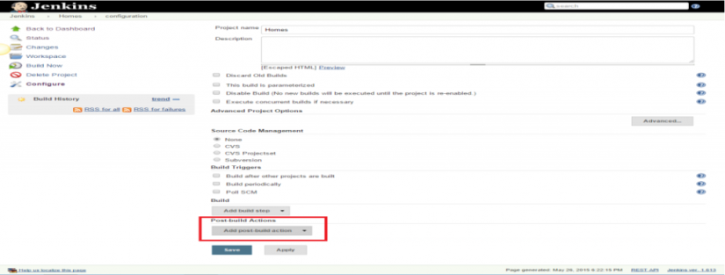](http://www.360logica.com/blog/wp-content/uploads/2016/02/image011.png)

11. Select the ‘E-mail Notification’ value.

[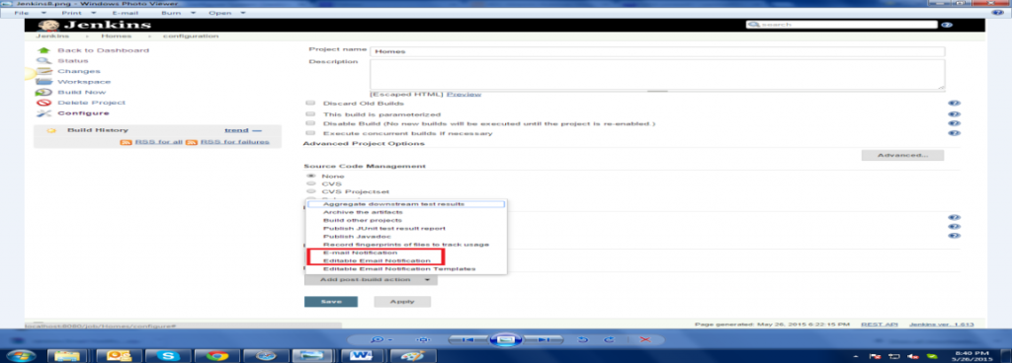](http://www.360logica.com/blog/wp-content/uploads/2016/02/image012.png)

12. Enter the recipient email id in the ‘E-mail Notification’ box and select the checkbox next to the ‘Send e-mail for every unstable build’ option.

[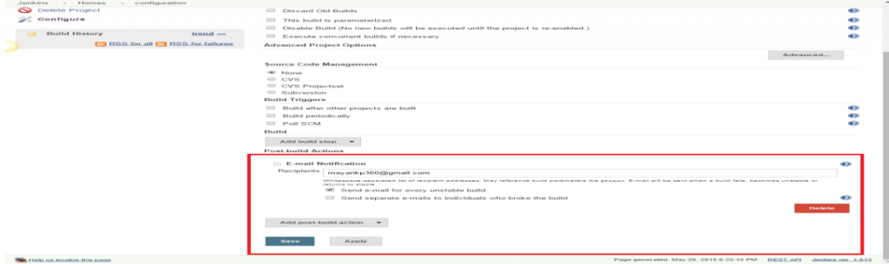](http://www.360logica.com/blog/wp-content/uploads/2016/02/image013.png)

13. Click the ‘Add post-build action’ drop-down and select the ‘Editable Email Notification’ value.

[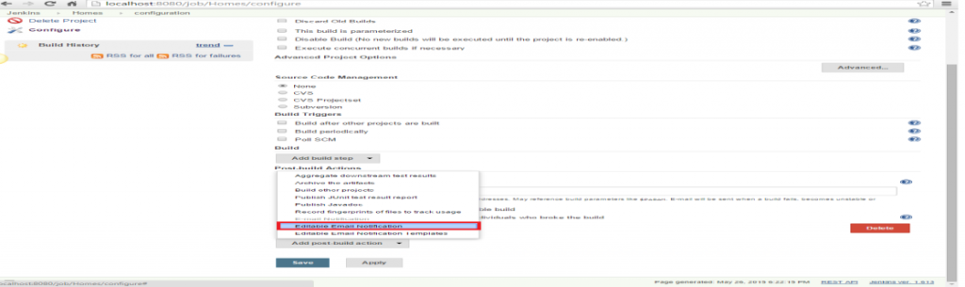](http://www.360logica.com/blog/wp-content/uploads/2016/02/image014.png)

14. Fill the ‘Editable Email Notification’ fields.

* Project Recipient List : email_id@gmail.com

[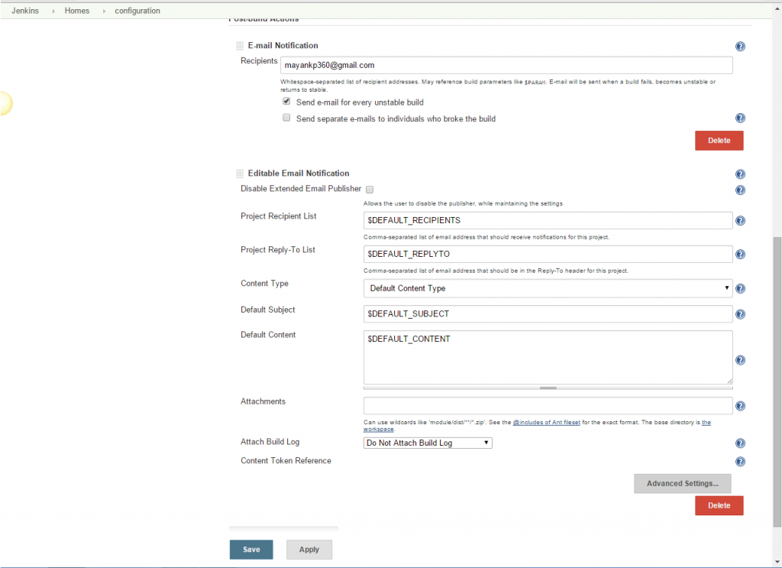](http://www.360logica.com/blog/wp-content/uploads/2016/02/image015.png)

15. Click the ‘Advance Settings…’ button in the ‘Editable Email Notification’ box.

16. Click the ‘Add Trigger’ drop-down and select the ‘Always’ option.

[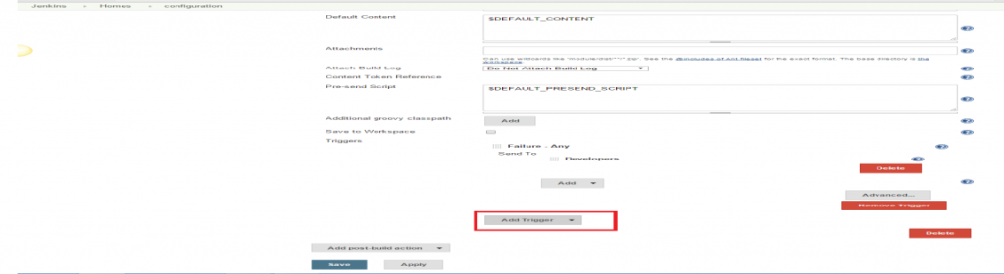](http://www.360logica.com/blog/wp-content/uploads/2016/02/image016.png)

[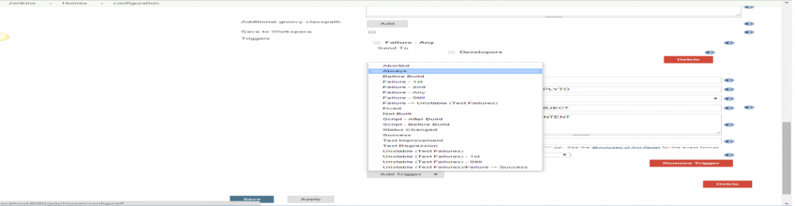](http://www.360logica.com/blog/wp-content/uploads/2016/02/image017.png)

17. Click the ‘Save’ button.

18. Go to the home page and click on the job, like Homes.

19. Click the ‘Build now’ link and check the email id after the job execution.

# Création slave node pour l’exécution de l’affichage de l’aperçu

1. Change acces permission for anonymous users
2. Modifier l’adresse de jenkins en utilisant l’adresse ip

Configure jenkins 🡪 System Configuration

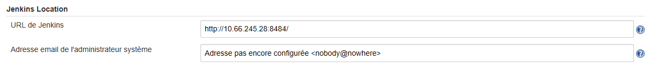

1. Activer le jnlp agent :

3.a. Configure jenkins🡪 Configure global security

3.b. Activate JNLP Agent

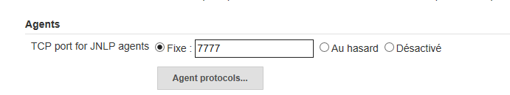

1. Create new slave node

4.a. Configure jenkins🡪 Manage Node

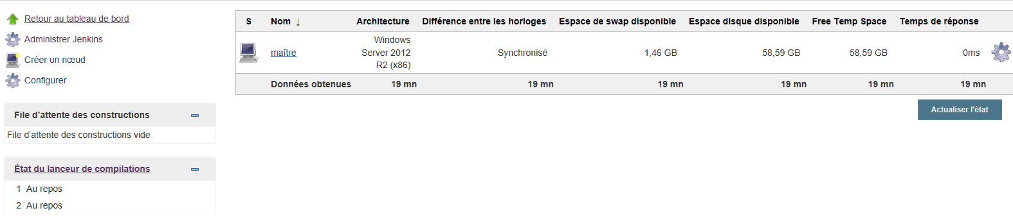

4.b. Create new node

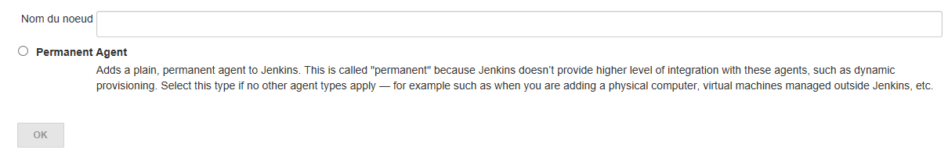

Set a number of executors : (one or more) as needed.

Set a Remote FS Root :

* A home directory for the master on the agent machine.
* For a Windows agent, use something like: "C:\Jenkins_Slave\"

Select the appropriate Usage setting:

* For an additional worker: Utilize this node as much as possible
* For specialized jobs: Leave this machine for tied jobs only

Launch Method:

* An easy way to control a Windows agent is by using Launch agent via Java Web Start  (Recommended for Windows)
* TODO: add steps for other methods.

Availability :

* Keep this agent online as much as possible
* TODO: add details for each option.

Press OK.

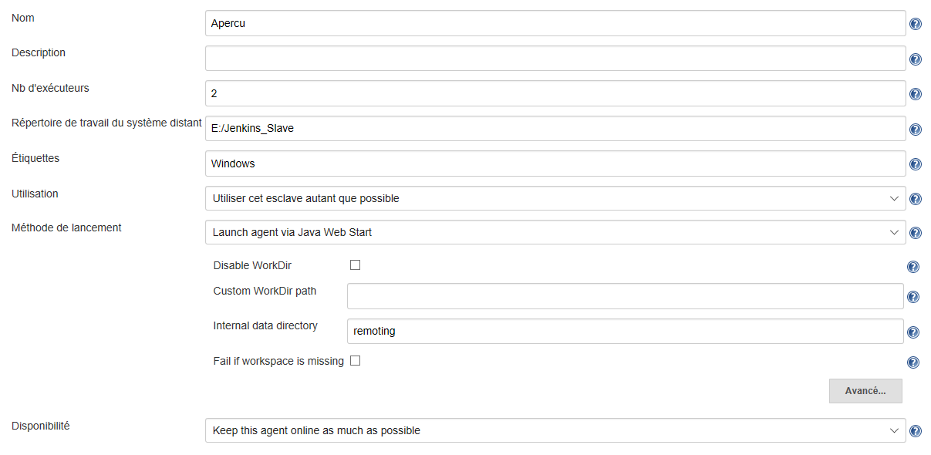

4.c. Add JNLP agent

* Create folder « c:\Jenkins_Slave »
* Copy in the folder « agent.jar »
* Execute the command in the cmd : « java -jar [agent.jar](http://10.66.245.28:8484/jnlpJars/agent.jar) -jnlpUrl http://10.66.245.28:8484/computer/Apercu/slave-agent.jnlp -workDir "E:/Jenkins_Slave" »

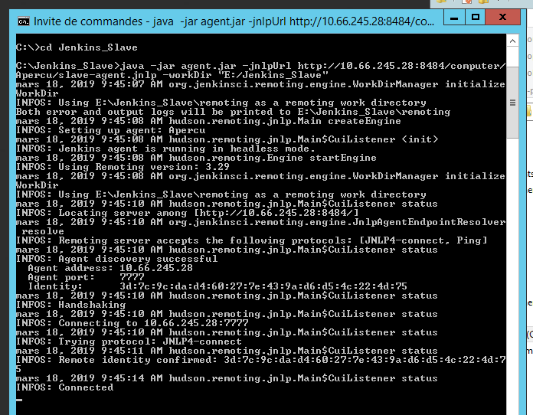

4.d. connect to your agent machine to the master using the following steps.

* Open a browser on the **agent machine** and go to the **Jenkins master server** url ([http://yourjenkinsmaster:8080](http://yourjenkinsmaster:8080/)).
* Go to **Manage Jenkins** > **Manage Nodes**,
* Click on the newly created agent machine. You will need to login as someone that has the "Connect" Agent permission if you have configured global security.

Click on the **Launch** button to launch agent from browser on agent.  
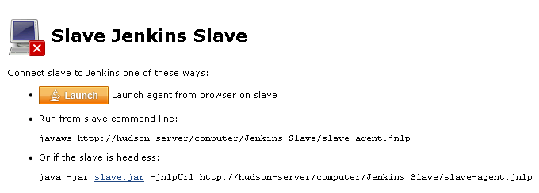

* Run the program.

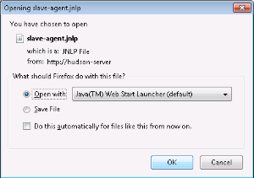

If Windows asks you to choose a program, use $JAVA_HOME\bin\javaws.exe (the Java Web Start Launcher).

If you encounter connection issue, then you could enlarge the popup windows to see the master **port used** and check your network configuration (firewall, port forward, ...).

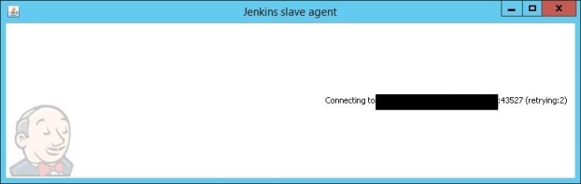

Note that Jenkins chooses a random, high-number port. If you want Jenkins to use a static port, go to "Manage Jenkins" > "Configure Global Security" and choose the port number in the "TCP port for JNLP agents" box.

If the port is open, the agent still can't connect, and your Jenkins instance is served securely over SSL/HTTPS, download and install the [Java Cryptography Extension (JCE) Unlimited Strength Jurisdiction Policy Files 8](http://www.oracle.com/technetwork/java/javase/downloads/jce8-download-2133166.html). Take the .jar files and save them to $JAVA_HOME\lib\security. Try the above steps again.

Now you should see the agent machine connected under **Nodes**.

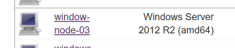

If you want the service to run on start-up of the agent machine do the following (Windows only directions):

In the agent program running on your agent machine, click **File** --> **Install as Windows Service.**

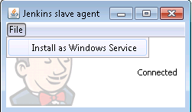

Note that this feature requires ".Net Framework 3.5"  


**Start**, type Services and Select the **Services** program.

Find **Jenkins Agent** in the list, Double click to open.

Select **Startup type** --> **Automatic**.

Go to the **Log On** tab, change the **Log on as** to a user of your choice (Special user account Jenkins recommended).

Make sure that auto login is set for the agent machine for the user account, then the VM (or physical computer) should connect and be available when needed.

TODO: Add steps for connecting via ssh

Also: take a look at [Distributed builds](https://wiki.jenkins.io/display/JENKINS/Distributed+builds)

4.e. Associate your project to an esclave node

Une fois que vous avez affecté vos libellés à vos noeuds esclaves, vous devez aussi dire à Jenkins où il peut exécuter les tâches de build. Par défaut, Jenkins utilisera simplement le premier noeud esclave disponible, ce qui offre généralement le meilleur temps de traitement global. Si vous avez besoin d'attacher une tâche de build à une machine ou un groupe de machines particulier, vous devez cocher la case “Resteindre les emplacements où ce projet peut s'exécuter” dans la page de configuration du build (voir [Figure 11.15, “Exécuter une tâche de build sur un noeud esclave particulier”](https://jenkins-le-guide-complet.github.io/html/sect-build-job-ties.html#fig-jenkins-label-expression)). Ensuite, entrez le nom de la machine, ou un libellé identifiant un groupe de machines, dans le champ Expression de libellé. Jenkins fournira une liste déroulante dynamique montrant les noms de machines et libellés de au fur et à mesure que vous tapez.

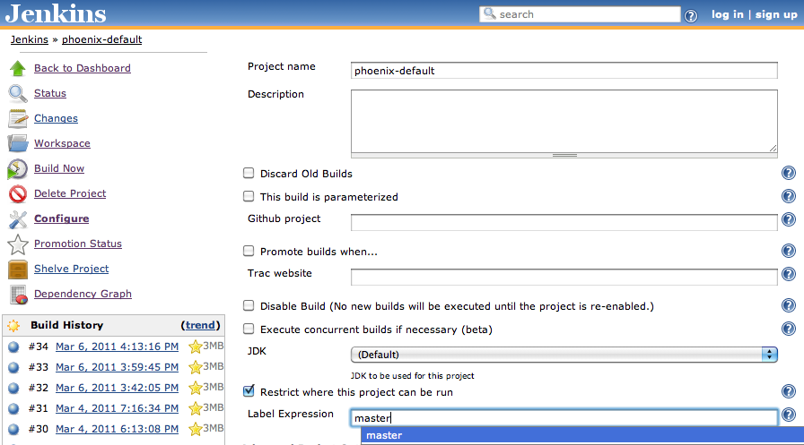

Figure. Exécuter une tâche de build sur un noeud esclave particulier

# Problem/Solution

* Element is not clickable at point (62,16), build using jenkins :

Modifiy **Element.click() ;** by

JavascriptExecutor executor = (JavascriptExecutor)driver;

executor.executeScript("arguments[0].click()", Element);

* Jenkins service can’t start 🡪Change port in jenkins.exe.config (current port :8484)
* Actions action = **new** Actions(driver);

action.moveToElement(WebElement).perform();

* Blockage SVN

Au niveau serveur -> ouvrir l’application « visual SVN server Manager »-> clic droite sur « visualSVN server » -> clic restart svn

* Effacer les fichiers temps généré par jenkins
* Pour les éléments dont les ids sont dynamique on utilise

WebDriver.findElement(By.*cssSelector*("*[id^=debut'][id$='fin’]"))

### ****How to Overcome Stale Element Reference Exception in Selenium:****

Use **public** **static** **void** waitElement(WebDriver driver, By by) defined in common class

# Working with Cucumber Data table

Cucumber data table is one of the most commonly used methods for passing test data from feature files to your test scripts. In our [previous article](http://www.automationtestinghub.com/practical-examples-cucumber-data-driven-testing/), you saw how we can pass string and numeric data from feature files, which Cucumber simply treats as variables.

With Cucumber data tables, you can pass parameters from feature files in tabular format. And you can then use this data in step definition methods in the form of **Lists**and **Maps**.

## Different ways of representing Cucumber data tables

In Cucumber, you can add data tables in two different formats –

* Data table with a header
* Data table without a header

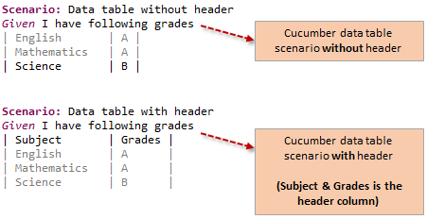

Here, a header means to have a top row which tells what type of data you have. You will get more clarity about this when you have a look at the examples of both these types of data tables.

Null pointer exception==🡺 suite non initialisation de la class page au niveau du class stepdef

PageFactory.*initElements*(driver, ModuleReunionPage.**class**);